*Being worried about managing control accounts? Let it be properly reconciled with CapActix control account solutions.*

***Managing cash flow in internal department definitely seeks wisdom and experience. We at CapActix, apply our past experiences and technology in analyzing misappropriations to make it work smartly.***

The commercial organizations have many control accounts to handle with a complete transparency. There are many designations in between the different vertices and control accounts. Well, the businesses do come across with the main four phases of **control accounts**. These four control accounts are to be reconciled for avoiding fraud and alleged misappropriation of funds. Following are the four control accounts to consider:

* Creditors Provide Inventory (Creditors to Inventory)
* Inventory is sold to Debtors (Inventory to Debtors)
* Debtors make payments against sales (Debtors to Cash & Bank)
* Cash and Bank is used to pay Creditors against purchases (Cash & Bank to Creditors)

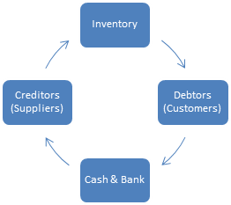

The businesses undergoes the continuous cycle of creditors to cash and bank with various demands. CapActix manages to keep a balance between the control accounts, its essentials, and businesses. We provide markable **reconciliation** **services** for the businesses.

We ensure accomplishing challenging tasks which are lacking in control systems and reconciliations of control accounts.

**Industries we have served**